**C:\Program Files (x86)\Microsoft Office\MEDIA\CAGCAT10\j0216858.wmf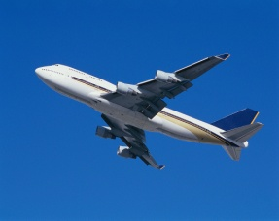Chapter 21 Review Transportation Power**

**Engines & motors produce the power we need to ___________________________________**

**_____________________________________________________________________________________________**

External Combustion Engine-______________________________________________

___________________________________________________________________

Steam Engine:_________________________________________________________

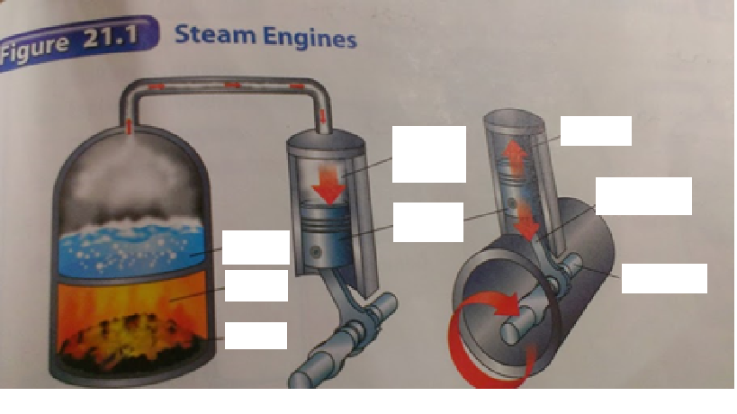___________________________________________________________________

C:\Users\Latkovich\AppData\Local\Microsoft\Windows\Temporary Internet Files\Content.IE5\MA4DHBZG\MC900356429[1].wmf

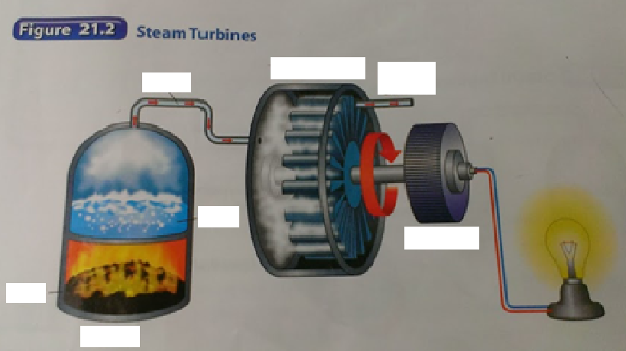SteamTurbine:___________________________________________________________________________________________________________________________

Internal Combustion Engine-______________________________________________

___________________________________________________________________

**Four-Stroke Cycle-**

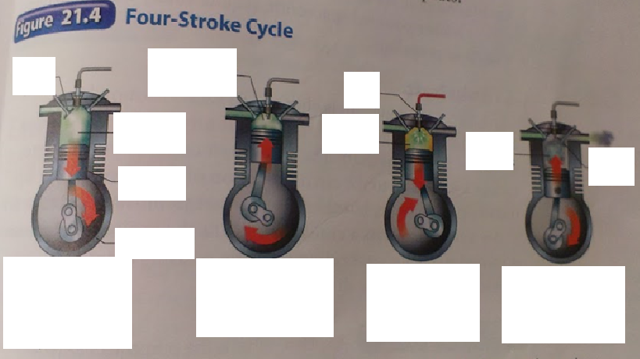

Intake stroke-________________________________________________________

___________________________________________________________________

Compression stroke-____________________________________________________

___________________________________________________________________

Power stroke-_________________________________________________________

___________________________________________________________________

Exhaust stroke-_______________________________________________________

___________________________________________________________________

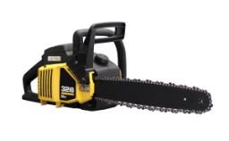Two-stroke engines-____________________________________________________

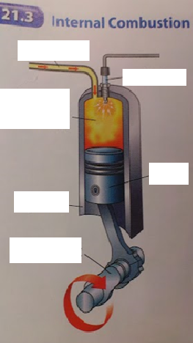___________________________________________________________________

___________________________________________________________________

___________________________________________________________________

Piston-______________________________________________________________

___________________________________________________________________

Rotary Motion-____________________________________

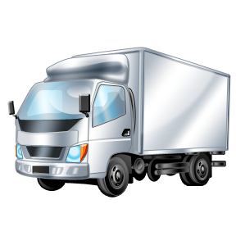

Crankshaft- _____________________________________

___________________________________________________________________

Diesel Engine- ________________________________________________________

___________________________________________________________________

___________________________________________________________________

Jet Engine-___________________________________________________________

______________________________________________________________________________________________________________________________________

Rocket Engine-________________________________________________________

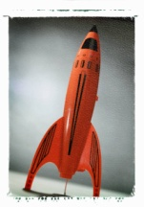______________________________________________________________________________________________________________________________________

Solid-propellant- ______________________________________________________

___________________________________________________________________

___________________________________________________________________

___________________________________________________________________

Liquid-propellant- ______________________________________________________

___________________________________________________________________

___________________________________________________________________

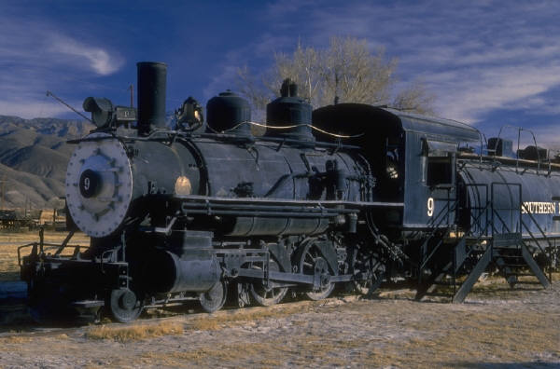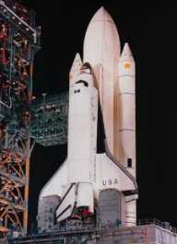______________________________________________________________________________________________________________________________________

Locomotives

Diesel-Electric locomotives- ______________________________________________

______________________________________________________________________________________________________________________________________

All-Electric Locomotives-_________________________________________________

___________________________________________________________________

___________________________________________________________________

Electric Cars-_________________________________________________________

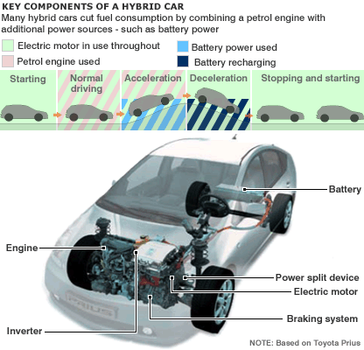______________________________________________________________________________________________________________________________________

Hybrid Car-___________________________________________________________

___________________________________________________________________

___________________________________________________________________

Fuel-Cell Automobiles-____________________________